AUSTRALIAN COMPETITION TRIBUNAL

Application by Port of Newcastle Operations Pty Ltd (No 3) [2022] ACompT 2
Review from: | The arbitration determination by the Australian Competition and Consumer Commission under section 44ZP of the Competition and Consumer Act 2010 (Cth) in relation to an access dispute between Glencore Coal Assets Australia Pty Ltd and Port of Newcastle Operations Pty Ltd
File numbers: | ACT 2 of 2018  ACT 3 of 2018
Tribunal: | O'BRYAN J (Deputy President)  DR D ABRAHAM (Member)  PROF K DAVIS (Member)
Date of Determination: | 5 April 2022
Catchwords: | COMPETITION – where applications made to Australian Competition Tribunal for review of arbitration determination made by the Australian Competition and Consumer Commission in respect of access dispute between provider and user of a declared service – where access dispute concerned amount of navigation service charge and wharfage charge at Port of Newcastle – where review conducted by the Tribunal by way of “re-arbitration” pursuant to s 44ZP of the Competition and Consumer Act 2010 (Cth) – where application made to Full Federal Court for judicial review of Tribunal’s arbitral determination – where Full Court set aside the determination of the Tribunal and remitted the applications to the Tribunal for re-determination according to law – where Full Court decision subsequently appealed to High Court of Australia – where High Court reinstated the Tribunal’s arbitral determination of the amount of the navigation service charge but remitted the question of scope of the navigation service charge to the Tribunal for re-determination – the Tribunal’s powers on the remitter – orders made varying final determination of Australian Competition and Consumer Commission in manner sought by Port of Newcastle Operations Pty Ltd and not opposed by Glencore Coal Assets Australia Pty Ltd
Legislation: | Administrative Appeals Tribunal Act 1975 (Cth) ss 43, 44  Competition and Consumer Act 2010 (Cth) ss 44V, 44ZP, 44ZR  Ports and Maritime Administration Act 1995 (NSW) ss 48(4)(b), 67
Cases cited: | Application by Medicines Australia Inc [2007] ACompT 4; ATPR 42-164  Application by Port of Newcastle Operations Pty Ltd [2019] ACompT 1  Australian Consumers’ Association’s Application (Re Media Council of Australia (No 2)) (1987) 82 ALR 115  Comcare v Chambers (No 2) (2017) 156 ALD 197  Glencore Coal Assets Australia Pty Ltd v Australian Competition Tribunal (2020) 280 FCR 194  Minister for Immigration and Multicultural Affairs v Wang (2003) 215 CLR 518  O’Sullivan v Australian Securities and Investments Commission (2018) 160 ALD 233  Peacock v Repatriation Commission (2007) 161 FCR 256  Port of Newcastle Operations Pty Ltd v Glencore Coal Assets Australia Pty Ltd [2021] HCA 39; 395 ALR 209  Re Herald & Weekly Times Ltd (1978) 17 ALR 281  Re Queensland Co-operative Milling Association Ltd (1976) 8 ALR 481  Shi v Migration Agents Registration Authority (2008) 235 CLR 286
Number of paragraphs: | 35
Date of last submissions: | 14 March 2022
Date of hearing: | Determined on the papers
Counsel for Port of Newcastle Operations Pty Ltd: | Mr CA Moore SC with Dr DJ Roche
Solicitor for Port of Newcastle Operations Pty Ltd: | Clayton Utz
Counsel for Glencore Coal Assets Australia Pty Ltd: | Mr N De Young SC
Solicitor for Glencore Coal Assets Australia Pty Ltd: | Clifford Chance
Counsel for Australian Competition and Consumer Commission: | Ms C Dermody
Solicitor for Australian Competition and Consumer Commission: | DLA Piper Australia

IN THE AUSTRALIAN COMPETITION TRIBUNAL
 | ACT 2 of 2018
Re: | APPLICATION BY PORT OF NEWCASTLE OPERATIONS PTY LTD UNDER SECTION 44ZP OF THE COMPETITION AND CONSUMER ACT 2010 (CTH) FOR REVIEW OF THE ARBITRATION DETERMINATION BY THE AUSTRALIAN COMPETITION AND CONSUMER COMMISSION IN RELATION TO AN ACCESS DISPUTE BETWEEN GLENCORE COAL LTD AND PORT OF NEWCASTLE OPERATIONS PTY LTD
PORT OF NEWCASTLE OPERATIONS PTY LTD
Applicant:
AND
 | ACT 3 of 2018
Re: | APPLICATION BY GLENCORE COAL ASSETS AUSTRALIA PTY LTD UNDER SECTION 44ZP OF THE COMPETITION AND CONSUMER ACT 2010 (CTH) FOR REVIEW OF THE ARBITRATION DETERMINATION BY THE AUSTRALIAN COMPETITION AND CONSUMER COMMISSION IN RELATION TO AN ACCESS  DISPUTE BETWEEN GLENCORE COAL LTD AND PORT OF NEWCASTLE OPERATIONS PTY LTD
GLENCORE COAL ASSETS AUSTRALIA PTY LTD
Applicant:
DETERMINATION
TRIBUNAL: | JUSTICE O’BRYAN (Deputy President)  DR D ABRAHAM (Member)  PROF K DAVIS (Member)
DATE OF DETERMINATION: | 5 APRIL 2022

THE TRIBUNAL DETERMINES THAT:
1. The Final Determination of the Australian Competition and Consumer Commission made under s 44V of the Competition and Consumer Act 2010 (Cth) dated 18 September 2018 be varied by making the amendments indicated (in mark-up) on the copy of the Determination annexed to these directions.
ANNEXURE
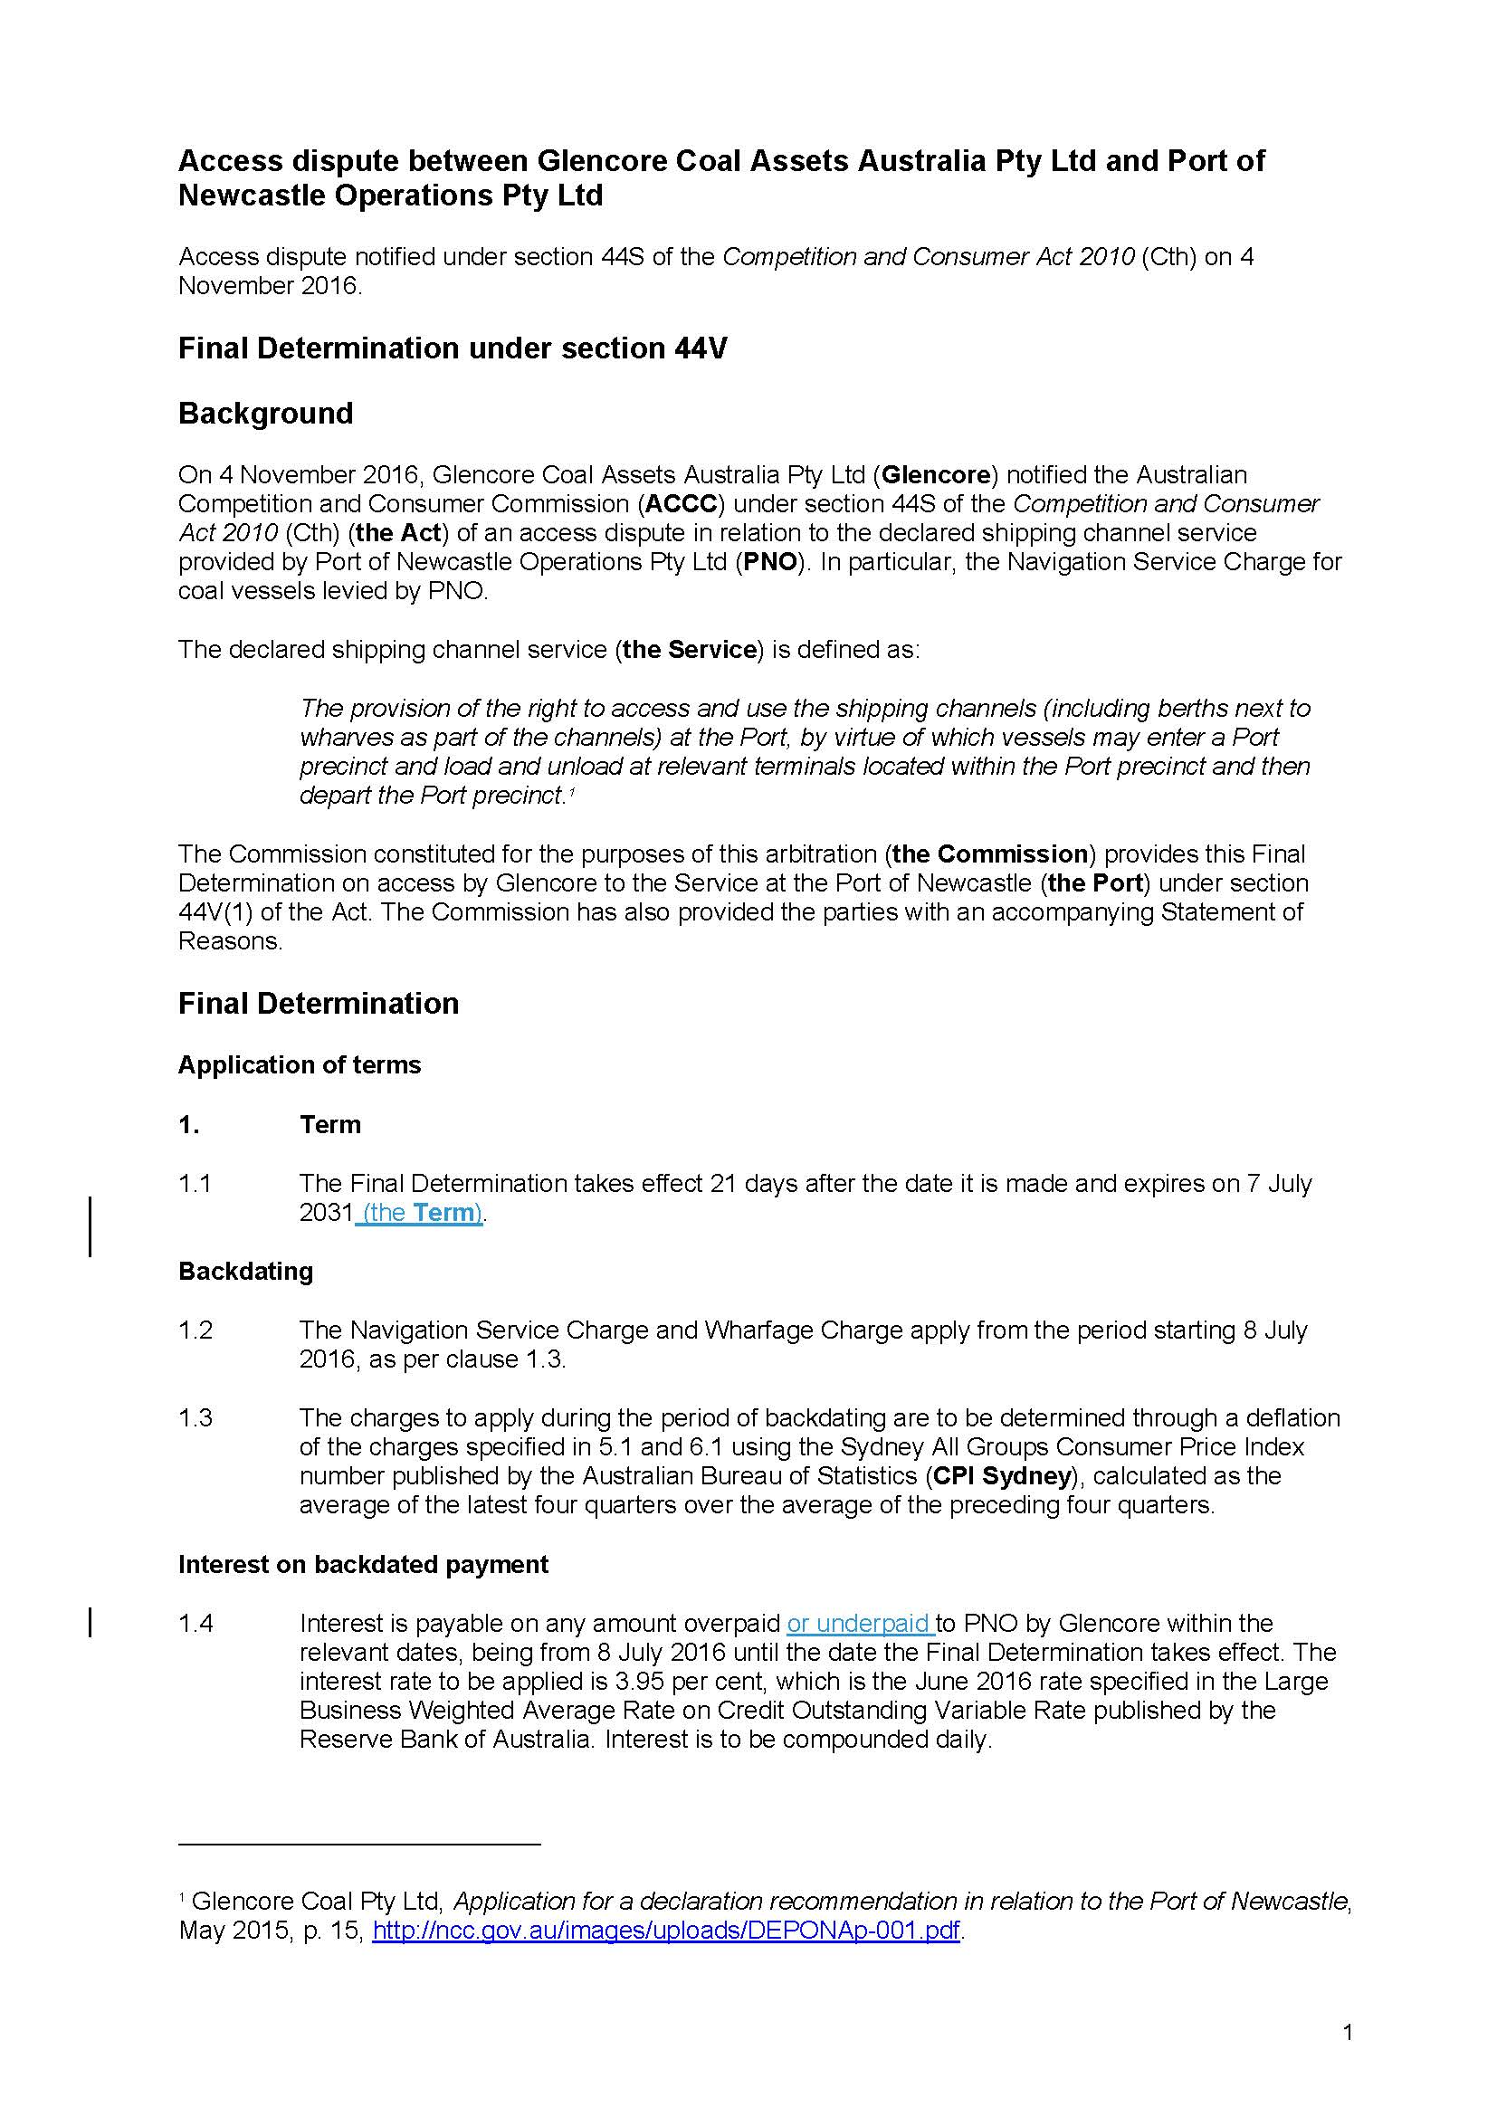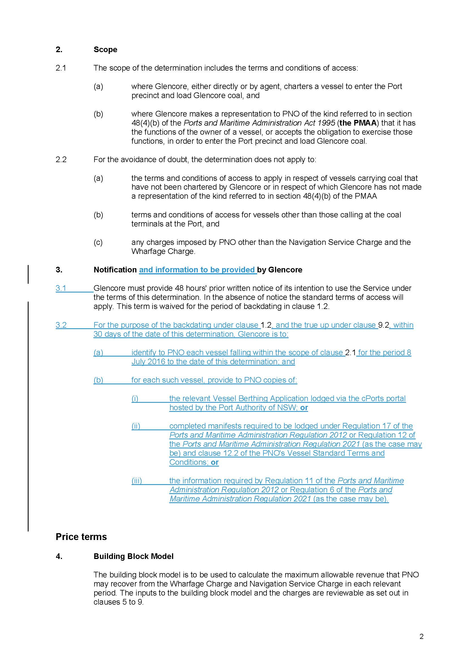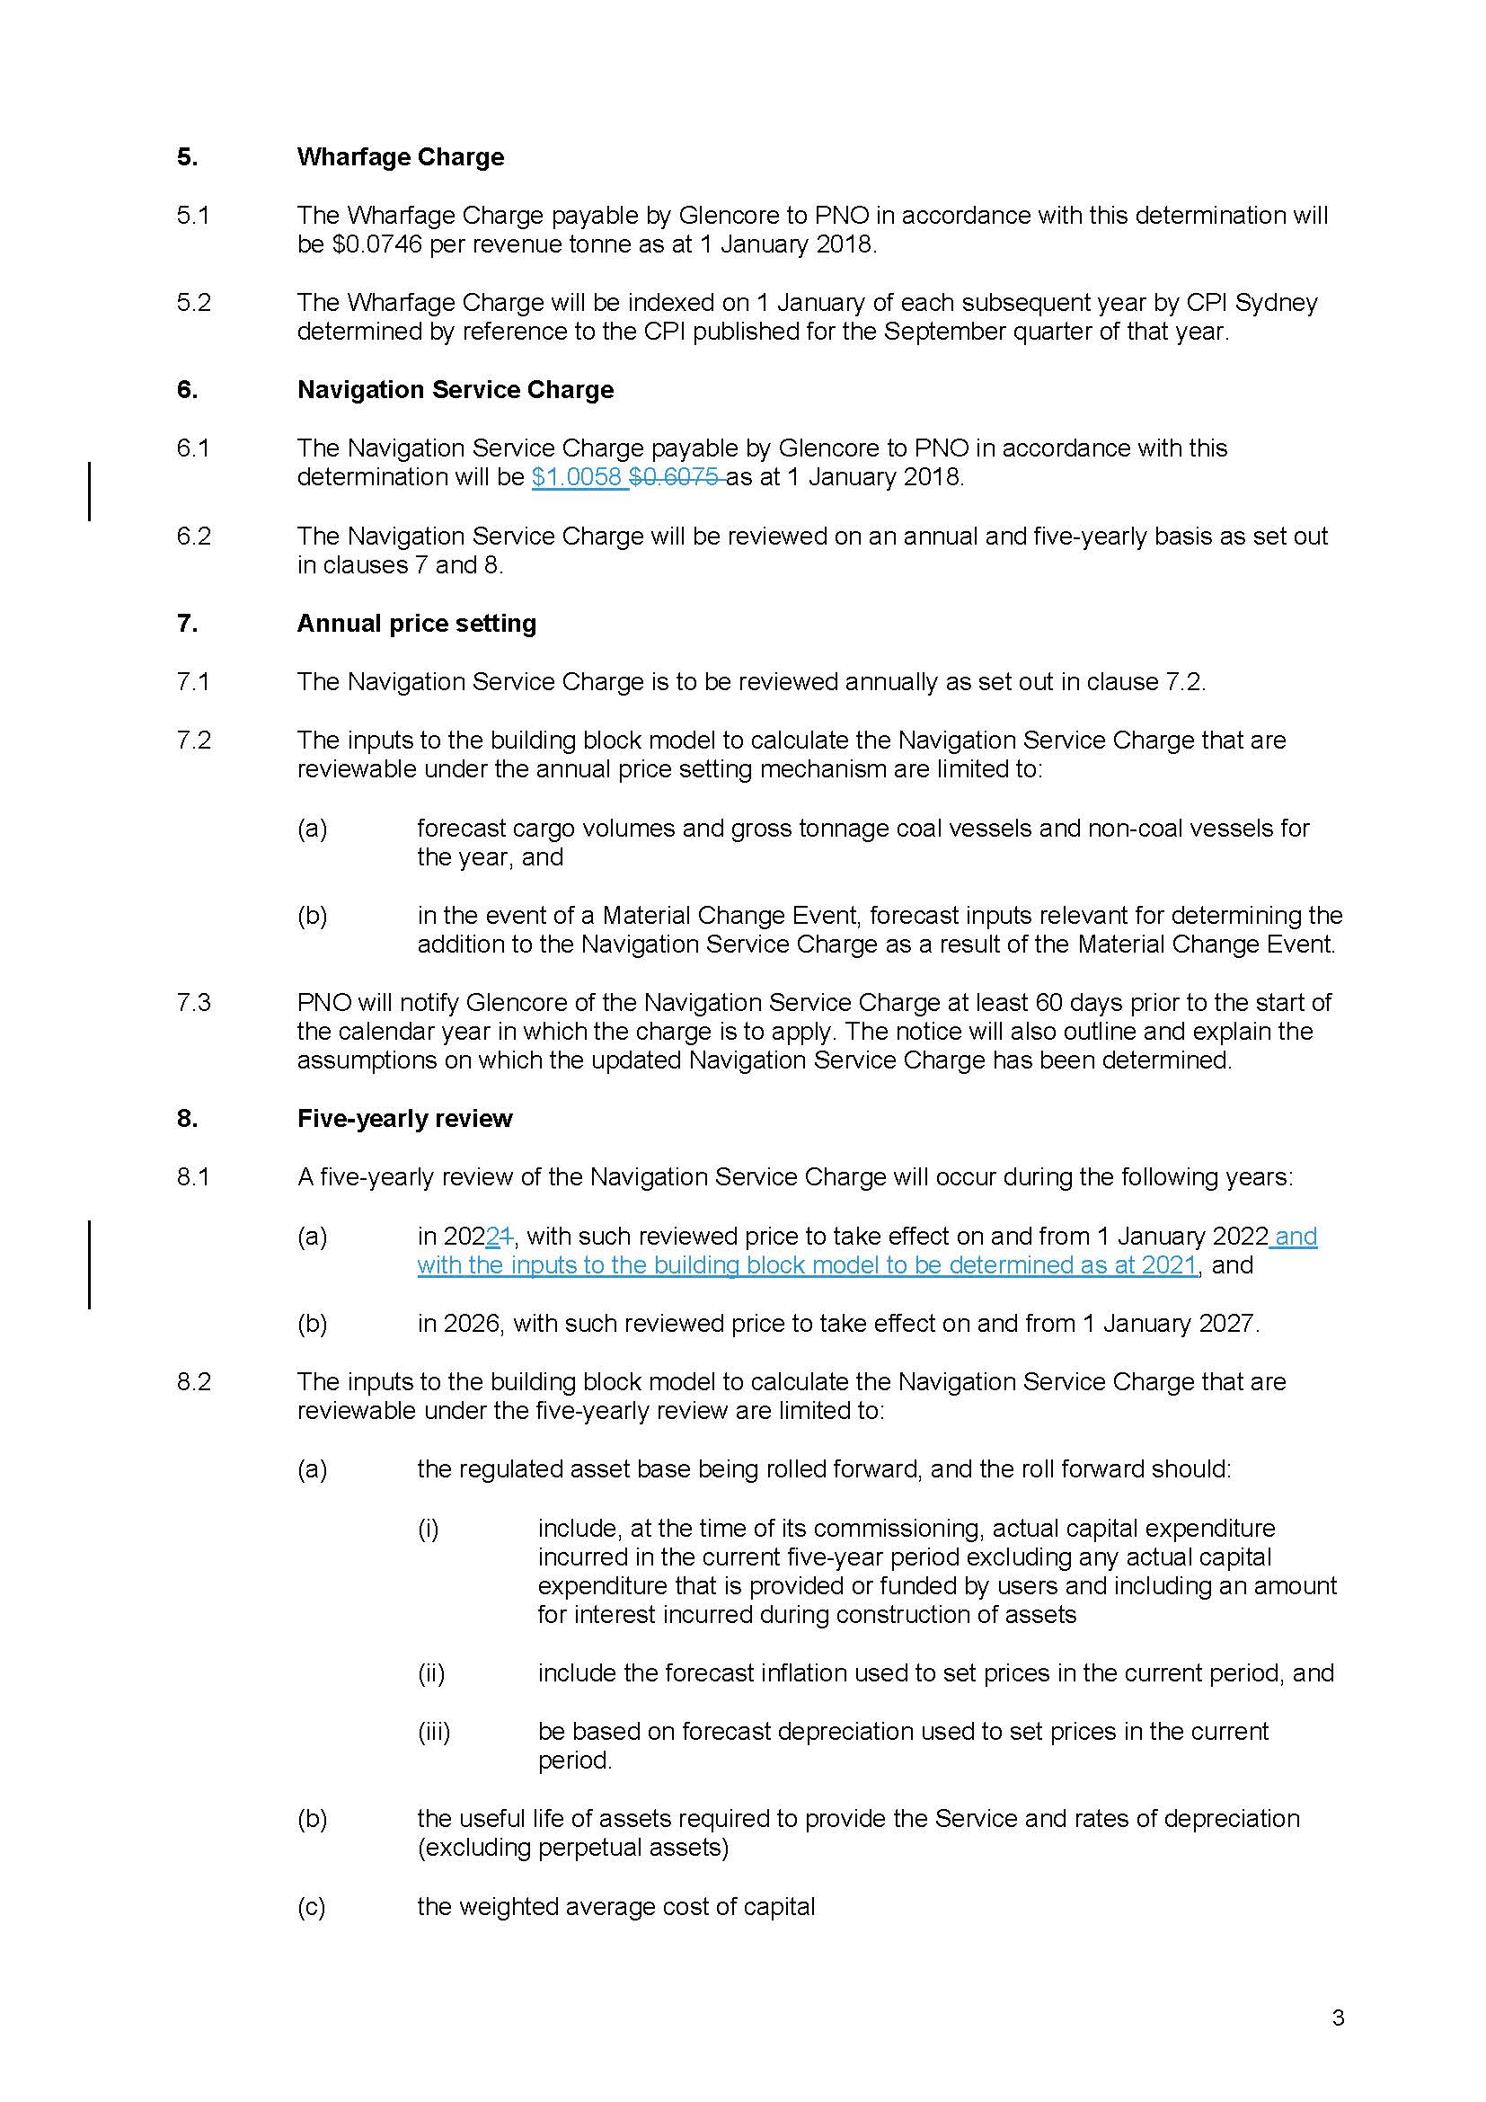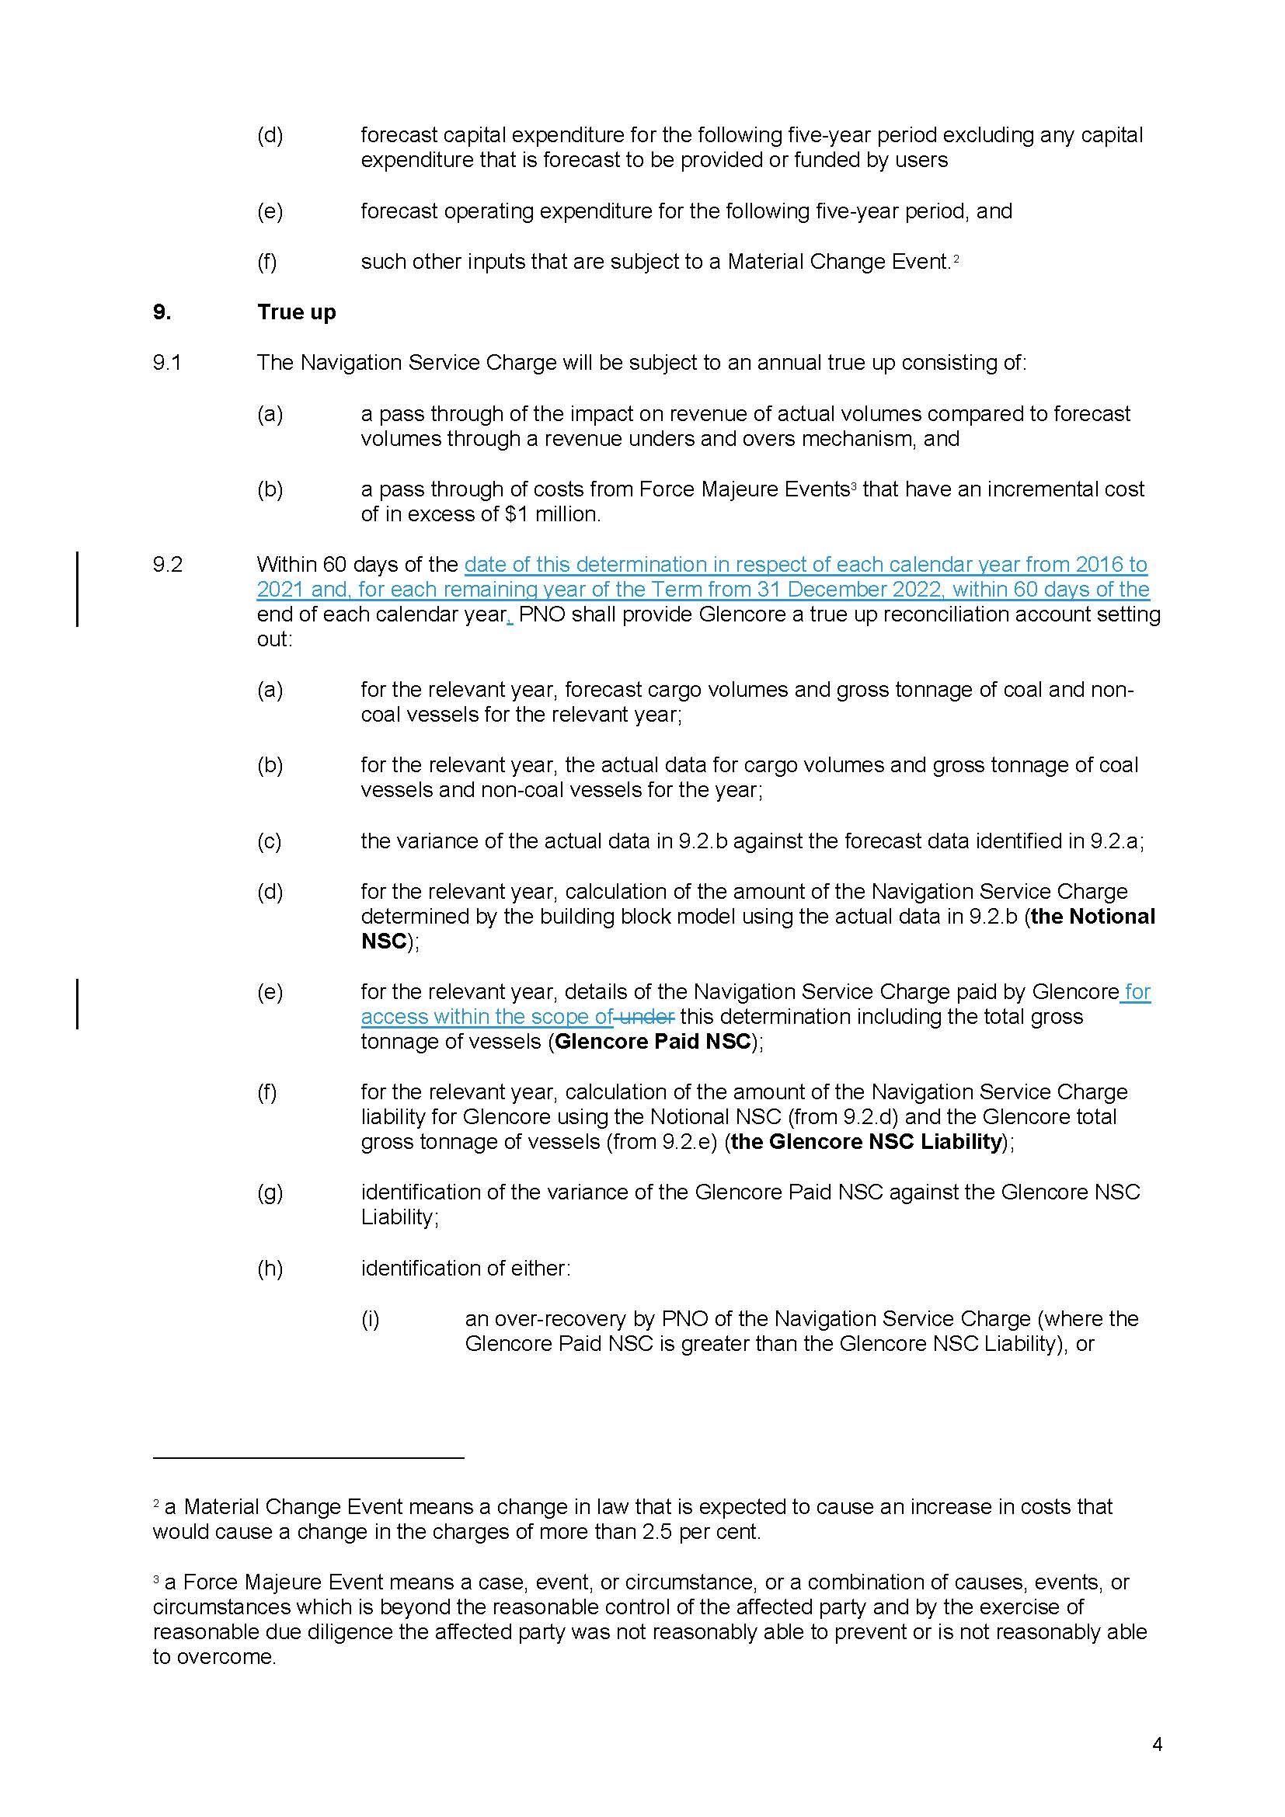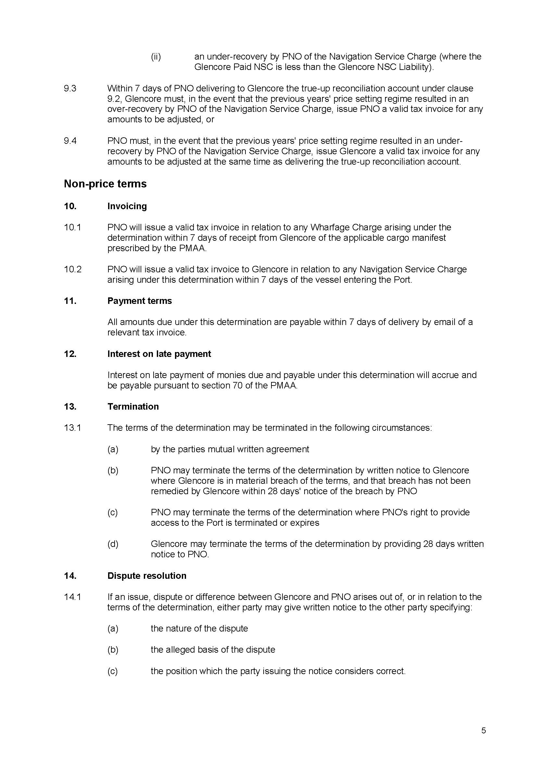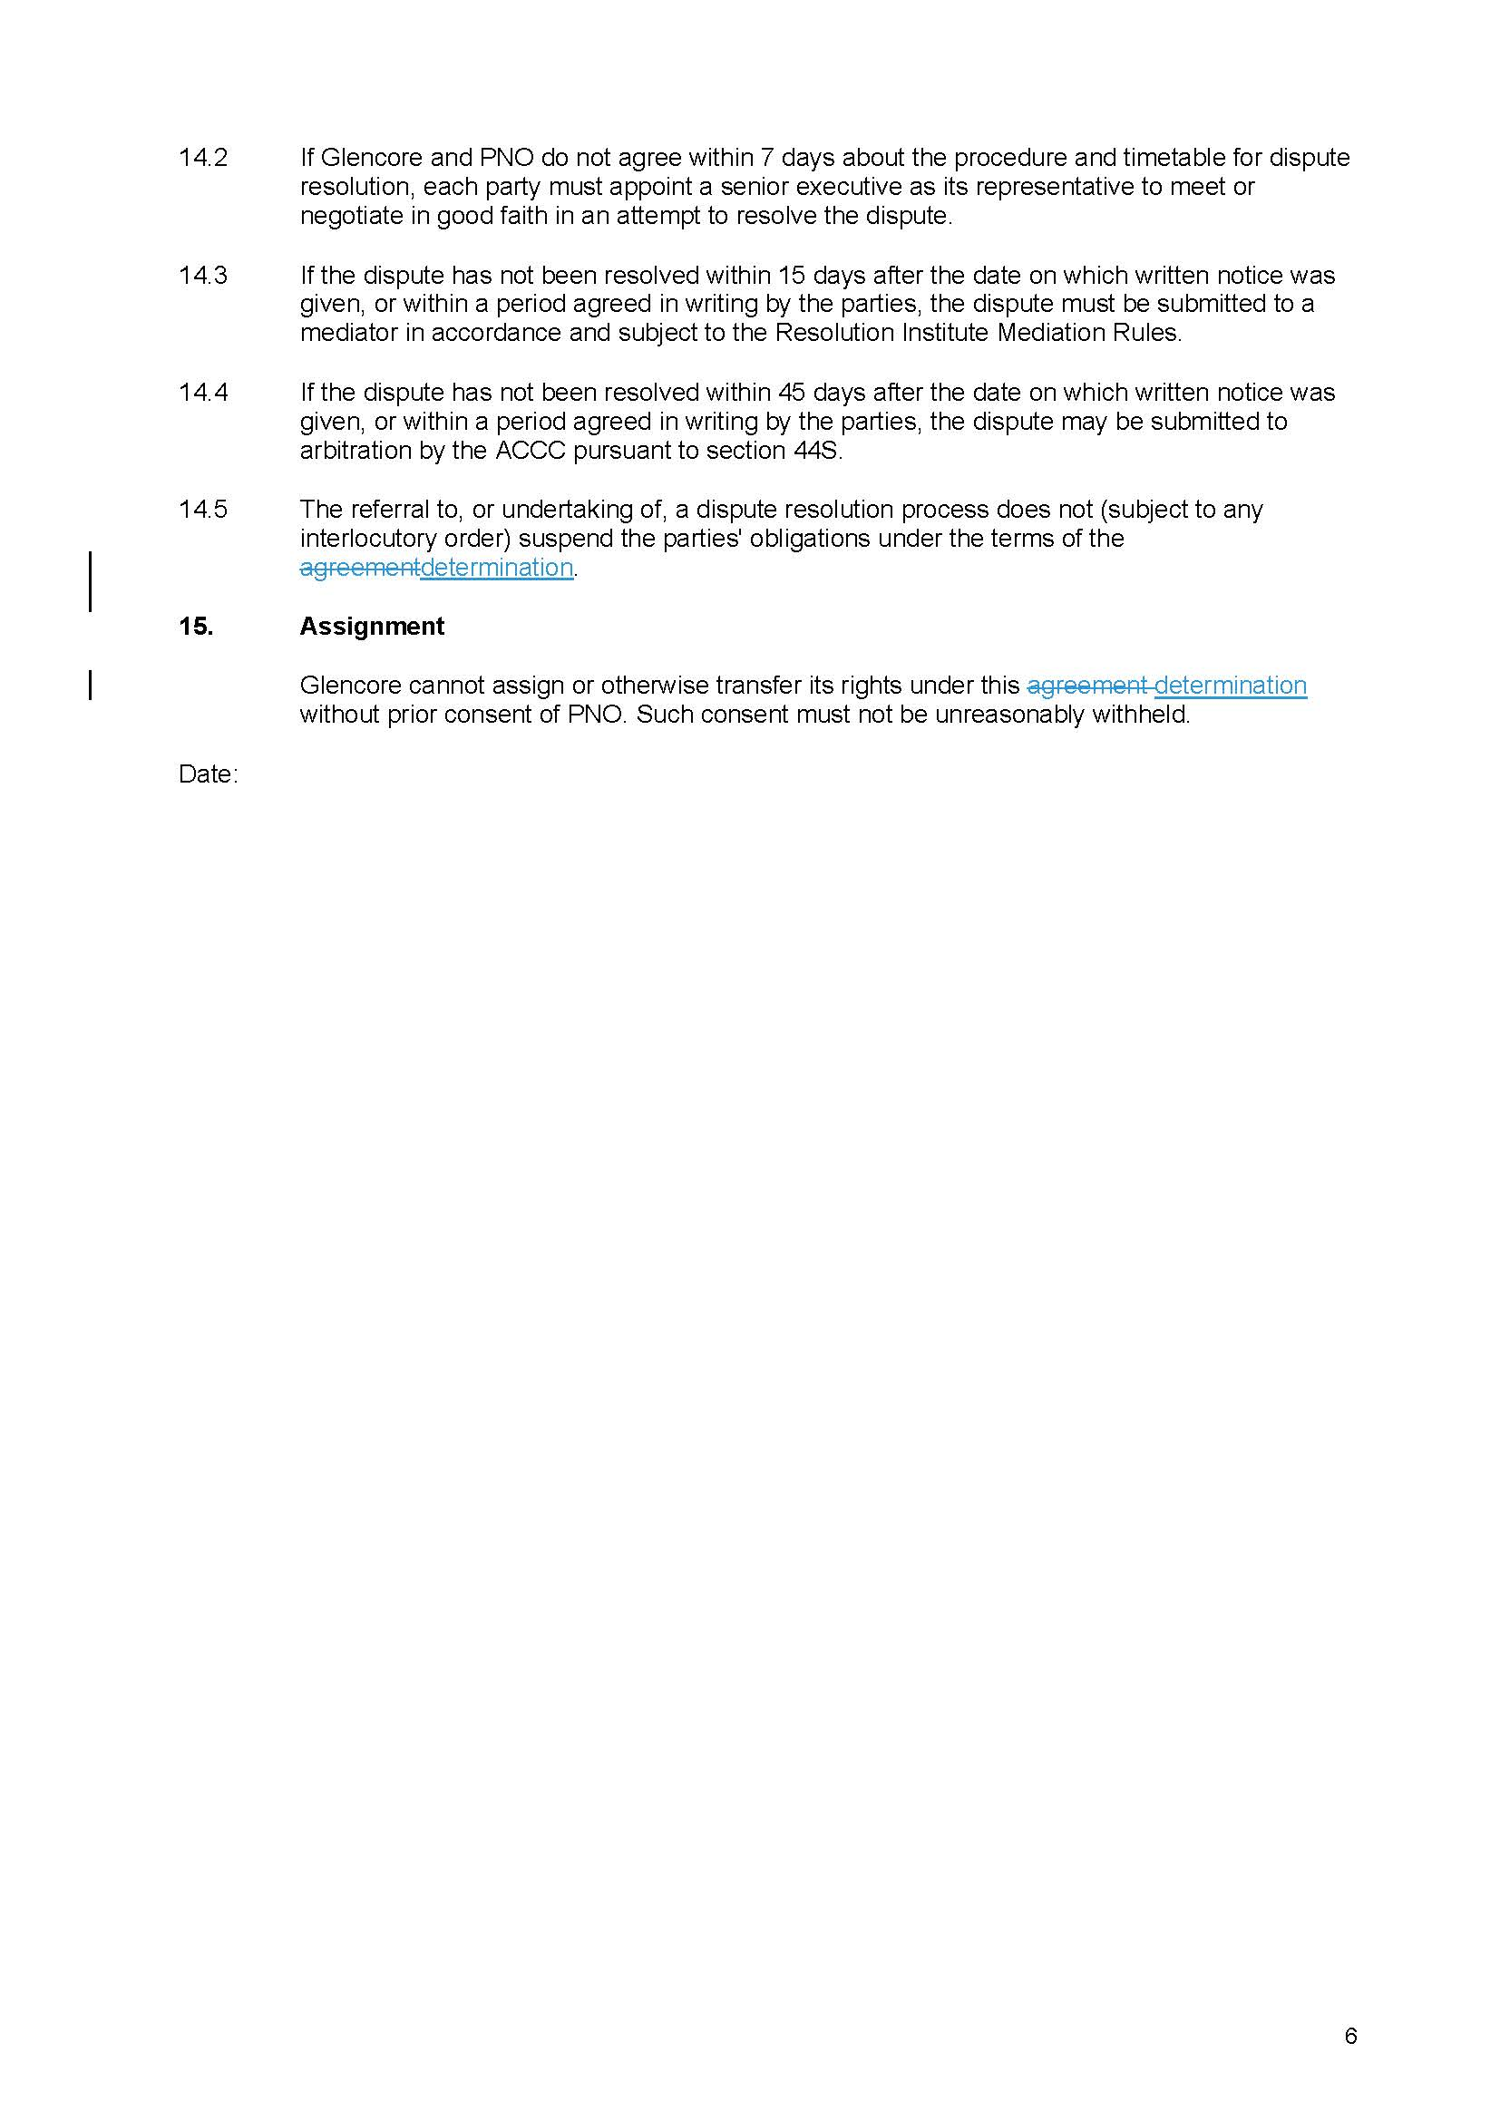

REASONS FOR DETERMINATION
THE TRIBUNAL:

Introduction
1 This matter concerns the terms on which Glencore Coal Assets Australia Pty Ltd (Glencore) can access the shipping channel service provided by Port of Newcastle Operations Pty Ltd (PNO) at the Port of Newcastle for the shipment of its coal from the Port. The parties have been in dispute about the terms of access from a time soon after the Port was privatised in 2014. The dispute has given rise to arbitration before the Australian Competition and Consumer Commission (ACCC), review of that arbitration before the Tribunal and judicial review of the Tribunal’s decision before the Courts.
2 The ACCC’s original arbitration determination was made on 18 September 2018. On review, the Tribunal varied the ACCC’s determination on 30 October 2019. The Tribunal’s determination was set aside by the Full Federal Court on 24 August 2020. The Full Federal Court’s decision was then varied by the High Court on 8 December 2021: Port of Newcastle Operations Pty Ltd v Glencore Coal Assets Australia Pty Ltd [2021] HCA 39; 395 ALR 209 (High Court decision). As a result of the High Court decision, the arbitration has been remitted to the Tribunal for re-determination in accordance with the conclusions of the High Court.
3 PNO has proposed a form of determination to be made by the Tribunal on remitter, together with supporting submissions. Glencore has informed the Tribunal that it does not oppose the Tribunal making the determination proposed by PNO.
4 PNO’s proposed form of determination varies the ACCC’s original arbitration determination in a number of respects that go beyond the legal issues determined by the High Court. A question arises as to the Tribunal’s power to make those variations on remitter.
5 For the following reasons, the Tribunal considers it appropriate to make the determination as proposed by PNO.

Background
6 On 4 November 2016, Glencore notified the ACCC under s 44S of the Competition and Consumer Act 2010 (Cth) (CCA) of an access dispute in relation to the declared shipping channel and berthing services at the Port of Newcastle provided by PNO, which activated the ACCC’s arbitration powers under Pt IIIA of the CCA. The dispute concerned the rates of the navigation service charge and wharfage charge levied by PNO in respect of the shipping channel service and berthing service respectively, and terms related to the imposition of those charges. Ultimately, though, the parties were agreed as to the rate of the wharfage charge.
7 On 18 September 2018, the ACCC made a final determination of the dispute under s 44V of the CCA. Two aspects of the determination should be noted. First, the ACCC determined an initial arbitral price for the navigation service charge as at 1 January 2018 of $0.6075 per gross tonne, which represented a significant decrease below the rates that had been charged by PNO since 2015. Clause 1.2 of the ACCC determination provided that the navigation service charge and wharfage charge, as determined by the ACCC, would be backdated so as to apply from 8 July 2016 with interest being payable on any amount overpaid to PNO by Glencore having regard to the ACCC determination. Second, the ACCC determined that the navigation service charge would apply in respect of vessels using the shipping channel service in two circumstances:
(a) where Glencore, either directly or by agent, charters a vessel to enter the Port precinct and load Glencore coal; and
(b) where Glencore makes a representation to PNO of the kind referred to in s 48(4)(b) of the Ports and Maritime Administration Act 1995 (NSW) (PMA Act) that it has the functions of the owner of a vessel, or accepts the obligation to exercise those functions, in order to enter the Port precinct and load Glencore coal.
8 On 8 October 2018, PNO filed an application for review of the ACCC determination pursuant to s 44ZP of the CCA (ACT 2 of 2018). On 9 October 2018, Glencore also filed an application for review (ACT 3 of 2018). By virtue of s 44ZO(1) of the CCA, the determination of the ACCC did not come into effect (by reason of the applications for review made to the Tribunal).
9 On 30 October 2019, the Tribunal (constituted by Middleton J, Mr R Shogren and Dr D Abraham) made a determination under s 44ZP of the CCA by which it varied the determination of the ACCC in two respects. The first concerned the amount of the navigation service charge. In that respect, the Tribunal determined an initial arbitral price for the navigation service charge as at 1 January 2018 of $1.0058 per gross tonne, which represented an increase to the rates that had been charged by PNO. The second concerned the description of the vessels using the shipping channels that were within the scope of, and were able to benefit from, the determination. In that respect, the Tribunal confined the determination to circumstances where Glencore, either directly or by agent, charters a vessel to enter the Port precinct and load Glencore coal. The Tribunal’s determination was published as Application by Port of Newcastle Operations Pty Ltd [2019] ACompT 1 (Application by Port of Newcastle Operations).
10 Glencore applied to the Full Federal Court for judicial review of the Tribunal’s arbitral determination in respect of both the level of the navigation service charge and the scope of the determination. On 24 August 2020, the Full Federal Court set aside the determination of the Tribunal and remitted the applications to the Tribunal for re-determination according to law. The Full Federal Court concluded that the Tribunal’s decision with respect to the navigation service charge and the scope of the determination were affected by errors of law: see Glencore Coal Assets Australia Pty Ltd v Australian Competition Tribunal (2020) 280 FCR 194.
11 PNO appealed the Full Court decision to the High Court. On 8 December 2021, the High Court delivered its judgment on the appeal. In respect of the navigation service charge, the High Court upheld PNO’s appeal and effectively reinstated the Tribunal’s arbitral determination of the initial navigation service charge of $1.0058 per gross tonne (as at 1 January 2018). In respect of the scope of the determination, the High Court accepted PNO’s appeal in part and dismissed it in part. The High Court concluded as follows (at [104]-[111], references omitted):
104 The Declaration, it will be recalled, relevantly described the Service as "the provision of the right to access and use the shipping channels (including berths next to wharves as part of the channels) at the Port". Plainly, the introductory reference to "the provision of the right to access" is surplusage. Having regard to the structure of the definition of "service" set out in s 44B of the Act, the service declared by the Declaration is "the use" of an infrastructure facility constituted by the shipping channels, which are treated for the purposes of the Declaration as including the berths.
105 In circumstances where Glencore wants to ensure that it can continue to enjoy the economic benefit that it unquestionably gets from the ability of ships, loading and carrying the coal that it sells to overseas buyers, to use the shipping channels and berths at the Port, Glencore is a person who wants "access" to the Service. Glencore is thereby a "third party". By operation of the Declaration, Glencore as a "third party" has a right to negotiate with PNO about the amount of the navigation service charge that PNO might fix for the Service. That is so whether Glencore sells FOB or CIF.
106 By exercising the right to negotiate through notifying an access dispute about the amount of the navigation service charge payable in respect of ships carrying the coal that it sells to overseas buyers either FOB or CIF, Glencore became entitled to an arbitrated bilateral outcome. The outcome to which Glencore became entitled was no less than could have been achieved without arbitration had PNO been willing to reach an agreement with Glencore about the amount of the navigation service charge payable by Glencore as permitted under the provisions of the PMA Act.
107 The Full Court was, on that basis and to that extent, correct to conclude that the Tribunal had erred in law in treating the permissible scope of the Final Determination as confined to circumstances where Glencore exercised some measure of control over the physical activity of moving a vessel through a shipping channel. The Full Court was therefore correct to set aside the Tribunal Decision and to remit the matter to the Tribunal for redetermination of the Final Determination.
108 Equally, however, the arbitrated outcome to which Glencore became entitled by exercising the right to negotiate was no more than could have been achieved without arbitration had PNO been willing to reach an agreement with Glencore about the amount of the navigation service charge payable by Glencore as permitted under the provisions of the PMA Act. The Full Court would have been incorrect to the extent that its additional observations, already quoted, might indicate that the Tribunal's re-arbitration of the access dispute could result in a determination governing the circumstances in which PNO would seek and accept payment of the Navigation Service Charge from a person other than Glencore in respect of the particular use of the shipping channels by a particular ship carrying coal sold by Glencore.
109 Subject to the constraints of tort and competition law, and to the provision of contractual consideration, one person can ordinarily enter into a binding contract with another person about the price at which that second person will offer a service to a third person. The third person will then become liable to pay the price to the second person under a separate contract that will be formed between the second person and the third person if and when the offer is made and accepted.
110 Here, however, the terms of the PMA Act do not permit PNO to enter into that kind of bilateral arrangement having potential consequences for a third person. It will be recalled that s 67 of the PMA Act relevantly goes no further than to permit PNO to enter into an agreement about the amount of the navigation service charge with a person who is liable to pay the navigation service charge. Absent any other person with a sufficient interest having chosen to become a party to the arbitration of the access dispute between PNO and Glencore, the only person who has the potential to become liable to pay the Navigation Service Charge as a result of the Final Determination is Glencore. When Glencore sells FOB, Glencore can answer the description of a person who is liable to pay the Navigation Service Charge only by acting to bring itself within the extended meaning of "owner" of a vessel in s 48(4)(b) of the PMA Act so as to accept the obligation to pay the Navigation Service Charge.
111 The Tribunal on remitter must therefore be confined to determining the circumstances in which the Navigation Service Charge will be payable by Glencore to PNO. In respect of the particular use of the shipping channels by a particular ship carrying coal sold by Glencore, the concern of the Tribunal will be to work out a practical mechanism to govern when and how Glencore will invoke s 48(4)(b) of the PMA Act to represent to PNO that it accepts the obligation to pay the Navigation Service Charge.
12 The High Court varied the orders of the Full Court such that the remitter to the Tribunal is confined to re-determining the scope of the navigation service charge (that is, the description of the vessels using the shipping channels to which the navigation service charge is applicable).

The Tribunal’s powers on the remitter
13 The Tribunal’s original power in this proceeding was conferred by s 44ZP of the CCA. In s 44ZP(3), the Tribunal’s review is described as a re-arbitration of the access dispute. The ordinary meaning of the word “re-arbitrate” is to arbitrate again. Together, subss 44ZP(4), (6) and (7) provide that:
(a) the Tribunal is given the same powers as the ACCC;
(b) the Tribunal may either affirm or vary the ACCC’s determination; and
(c) the Tribunal’s determination is taken to be a determination of the ACCC for all purposes of Pt IIIA.
14 The language of those subsections is similar to that found in many statutes that provide for review by an administrative tribunal of administrative decisions including, for example, subss 43(1) and (6) of the Administrative Appeals Tribunal Act 1975 (Cth) (AAT Act). The combined effect of subss 44ZP(4), (6) and (7) make clear that the Tribunal’s function is not limited to the identification and correction of error in the ACCC’s arbitral determination; the Tribunal’s function is to re-arbitrate the dispute between the access seeker and access provider: see Application by Port of Newcastle Operations at [4] and [36]. In that sense, the Tribunal “stands in the shoes” of the ACCC: O’Sullivan v Australian Securities and Investments Commission (2018) 160 ALD 233 at [36] per Perram J, citing Shi v Migration Agents Registration Authority (2008) 235 CLR 286 at [40], [100] and [134]. In that respect, the Tribunal’s functions and powers are analogous to those conferred under Pt IX of the CCA: see for example Re Queensland Co-operative Milling Association Ltd (1976) 8 ALR 481 at 486 (Woodward J, Mr J Shipton and Prof M Brunt); Re Herald & Weekly Times Ltd (1978) 17 ALR 281 (Re Herald & Weekly Times) at 295-296 (Deane J, Mr J Shipton and Mr J Walker); Australian Consumers’ Association’s Application (Re Media Council of Australia (No 2)) (1987) 82 ALR 115 at 126 (Lockhart J, Prof M Brunt and Dr B Aldrich); Application by Medicines Australia Inc [2007] ACompT 4; ATPR 42-164 at [135] and [138] (French J, Mr G Latta and Prof C Walsh). As those decisions of the Tribunal make clear, the task of the Tribunal is not to review the reasons of the decision-maker, but the reasons may “prove a convenient reference point for defining the matters which are truly in dispute” (Re Herald & Weekly Times at 296).
15 A particular feature of the ACCC’s functions and powers under Div 3 of Pt IIIA, which are given to the Tribunal on re-arbitration, should be noted. As observed by the Tribunal in Application by Port of Newcastle Operations at [32], access disputes within the context of Pt IIIA are bilateral in nature. The ACCC is empowered to arbitrate a notified dispute between an access seeker (referred to as a third party) and the access provider. The arbitral determination that is made by the ACCC under s 44V is binding only on the parties to the arbitration and has no wider application. The issues in dispute are defined by the parties to the arbitration. The issues will generally be defined by the original notification of the dispute to the ACCC under s 44S, but the ACCC is empowered by s 44V(2) to deal with any matter relating to access by the third party to the service, including matters that were not the basis for notification of the dispute. The ACCC’s powers are subject to certain restrictions set out in s 44W and certain mandatory considerations set out in s 44X. In conducting the re-arbitration, the Tribunal performs the same function and exercises the same powers subject to the same restrictions and mandatory considerations.
16 The Tribunal’s powers on remittal are governed by the orders of the Full Court, as varied by the orders of the High Court. Those orders were made under s 44ZR(4) of the CCA which provides that the Court may make orders setting aside the decision of the Tribunal and remitting the matter to be decided again by the Tribunal in accordance with the directions of the Court. It can be noted that that provision is similar in form to s 44(5) of the AAT Act.
17 In the present matter, the Full Court set aside the original determination of the Tribunal and remitted the matter to the Tribunal for “determination according to law”. It was implicit in that order that the further determination by the Tribunal is to be made in a manner that gives effect to the Full Court’s conclusions on the specific legal issues in dispute before the Full Court. In the course of its reasoning, the Full Court emphasised that its decision concerned the legal framework within which the Tribunal’s decision was made; whereas matters of fact and economic analysis are for the Tribunal to determine. The Full Court observed (at [5]):
… This Court, on review, is concerned with whether the legal framework for decision-making was observed and whether the law was properly understood and applied by the Tribunal in making its decision. Matters of fact and contextual economic analysis are for the Tribunal. As has been observed previously in a number of decisions in which review has been sought of a Tribunal decision under Pt IIIA, it is not this Court’s function to resolve the difficult and complex matters of judgment the Tribunal may be called upon to resolve (and thereby slide into impermissible merits review) but is rather to ensure the decision of the Tribunal accords with the law: Australian Energy Regulator v Australian Competition Tribunal (No 2) (2017) 255 FCR 274; 345 ALR 1; 155 ALD 474; [2017] FCAFC 79 at [44], [133].
18 Consistently with that observation, while the Full Court concluded that the Tribunal had erred in law when defining the scope of the determination, the Full Court confirmed that it was for the Tribunal, on remittal, to define the scope of the determination. The Full Court concluded (at [169]):
… It is, however, for the Tribunal, not this Court, to fashion the scope of the terms. We would set aside the determination and remit the matter to the Tribunal to fix the terms of the scope of the determination in the light of these reasons. The working out of arrangements in the terms of access for Glencore to stipulate a mechanism by which the determined access price would apply to ships carrying coal from Glencore’s mine would also be a matter for the Tribunal in the re-arbitration.
19 The Full Court also concluded that the Tribunal had erred in law with respect to its determination of the navigation service charge. The Full Court similarly remitted the determination of that charge to the Tribunal. The High Court overruled that aspect of the Full Court’s decision and varied the Full Court’s order by adding an additional order which stipulated that: “[t]he determination according to law by the Tribunal on remitter pursuant to order 1 be confined to redetermining the scope of the Navigation Service Charge".
20 It is well established that, in the absence of an express or implied restriction, an order under s 44(5) of the AAT Act remitting a matter to the Administrative Appeals Tribunal for determination in accordance with law requires the Tribunal to determine all questions of fact and law relevant to the matter in accordance with the information and circumstances prevailing at the time of the new determination: see Minister for Immigration and Multicultural Affairs v Wang (2003) 215 CLR 518 at [6]-[7] per Gleeson CJ; Peacock v Repatriation Commission (2007) 161 FCR 256 at [12]-[20] per Downes, Lander and Buchanan JJ. The order acts as a remittal of the whole matter in which it is open to the Tribunal to reconsider any aspect of the remitted matter.
21 The Tribunal considers that, in the present matter, the Full Court’s order, as varied by the High Court, should be understood in the same manner. The order requires the Tribunal to decide again the access dispute in light of the legal issues ultimately determined by the High Court. Generally, it is for the Tribunal to determine the conduct of any further hearing that may be required on remitter, including whether any further evidence may be permitted to be adduced (cf Comcare v Chambers (No 2) (2017) 156 ALD 197 at [6]-[8] per Perram J). The Tribunal has the power to determine any issue raised by the parties on the remitter.
22 In the present matter, neither party has sought to adduce further evidence. However, PNO has raised certain additional issues that go beyond the legal issues determined by the High Court. The Tribunal considers that it may, on the remitter, vary the ACCC’s arbitral determination in additional respects where those amendments are sought by agreement of the parties, or where they are sought by one of the parties and are not opposed by the other party, and where the amendments are within the powers given to the ACCC under Div 3 of Pt IIIA.

Proposed determination on remitter

Initial value of the navigation service charge
23 As a result of the High Court decision, the Tribunal’s arbitral determination of the initial navigation service charge of $1.0058 per gross tonne (as at 1 January 2018) has been reinstated. The Tribunal will therefore vary the ACCC determination by inserting that figure in cl 6.1 of the arbitral determination.

Scope of the determination
24 The High Court concluded that the Tribunal erred in law in confining the scope of the determination to circumstances where Glencore, either directly or by agent, charters a vessel to enter the Port precinct and load Glencore coal. As the above extract of the High Court’s reasons explains, leaving aside the terms of the PMA Act, Glencore would have the right to negotiate with PNO about the amount of the navigation service charge that PNO might fix for the shipping channel service whether Glencore sells under “free on board” (FOB) or “cost, insurance and freight” (CIF) contracts. As such, Glencore would have the right to notify an access dispute, and seek arbitration, in respect of the navigation service charge to apply in respect of ships carrying the coal that it sells to overseas buyers either FOB or CIF. However, s 67 of the PMA Act limits PNO’s ability to enter into an agreement with Glencore in respect of the navigation service charge when Glencore sells FOB. In respect of FOB sales (where the coal buyer arranges shipping from the Port), Glencore can answer the description within s 67 of a person who is liable to pay the navigation service charge only by acting to bring itself within the extended meaning of “owner” of a vessel in s 48(4)(b) of the PMA Act so as to accept the obligation to pay the navigation service charge.
25 In light of the High Court’s conclusion concerning the scope of the determination, PNO proposed that the Tribunal make no change to the ACCC’s arbitral determination on this issue. It will be recalled that the ACCC determined that the navigation service charge would apply in respect of vessels using the shipping channel service in two circumstances:
(a) where Glencore, either directly or by agent, charters a vessel to enter the Port precinct and load Glencore coal; and
(b) where Glencore makes a representation to PNO of the kind referred to in s 48(4)(b) of the PMA Act that it has the functions of the owner of a vessel, or accepts the obligation to exercise those functions, in order to enter the Port precinct and load Glencore coal.
26 The Tribunal agrees that the ACCC’s arbitral determination on this issue is consistent with the High Court’s ruling.

Other amendments sought by PNO
27 PNO seeks additional amendments to the wording of the ACCC’s arbitral determination with the expressed aim of giving it workable effect in light of the Tribunal’s determination and also the effluxion of time. The original determination was stated to apply from 8 July 2018, with the parties to account for differences in charges (plus interest) in the interim period until the determination comes into effect. That will now be a period of more than three and a half years. The additional amendments proposed by PNO were not opposed by Glencore. A brief description of the amendments sought by PNO follows.

Clause 1.4
28 Clause 1.4 of the ACCC’s arbitral determination provides for the payment of interest on any backdated payment. As originally drafted, the clause was confined to the payment of interest in respect of any overpayment to PNO by Glencore. It did not apply in the case of any underpayment to PNO. No doubt this reflected the fact that, at the time of the ACCC determination, the navigation service charge determined by the ACCC was lower than the amount charged by PNO. Under the Tribunal’s determination, the opposite is the case. PNO seeks the addition of the words “or underpaid”, so that the clause refers to “any amount overpaid or underpaid”.

Clause 3.2
29 In order to calculate the navigation service charge payable during the period of backdating, and in order to perform the “true-up” provided for by cl 9, PNO requires certain information, including which Glencore vessels fell within the scope of the determination (as set out in cl 2.1), and their gross tonnages. As presently drafted, the ACCC determination does not contain any mechanism for Glencore to provide this information to PNO. Clause 3.2 addresses this gap in the determination. It requires Glencore to identify the vessels covered by the determination in the period 8 July 2016 to the date of the determination and to provide information that will enable PNO to ascertain and verify the gross tonnage of each vessel covered by the determination.

Clause 8
30 Clause 8 provides for a five-yearly review of the navigation service charge. As originally drafted, the first review was required to take place in 2021. This was not possible, as the determination had not come into effect by 2021 (due to the parties’ subsequent applications and appeals to the Tribunal, Federal Court and High Court). The amendment provides that the review is to take place in 2022 with (backdated) effect from 1 January 2022 but using information from 2021 as was originally intended.

Clause 9
31 Clause 9 provides for an annual “true-up” of the navigation service charge. This provision is necessary because both the initial navigation service charge determined by the ACCC, and subsequent annual revisions (cl 7) are calculated using forecast, rather than actual, cargo volumes. Under the building block model used by the ACCC, the maximum allowable revenue (MAR) is recoverable by PNO through the navigation service charge and the wharfage charge. To calculate the navigation service charge (charged per vessel gross tonne), the proportion of MAR allocated to the navigation service charge was divided by the forecast cargo volume for the Port. This generated the initial figure of $1.0058 (as at 1 January 2018). Clause 7 provides for these forecasts to be reviewed annually. Clause 9 provides for the navigation service charge to be recalculated at the end of each year based on actual volumes, and also provides for a reconciliation of that figure (described in the determination as the Notional NSC) against the navigation service charge actually paid by Glencore (described as the Glencore Paid NSC).
32 As a result of the delay in the making of the final determination, the annual true-up process is yet to occur. This clause therefore requires some minor adjustment. First, in the chapeau of cl 9.2 there is a provision for the relevant calculation for the past period to occur within 60 days of the date of determination (rather than 60 days from the end of each year, where those years now lie in the past). Secondly, in cl 9.2(e) the reference to paid “under this determination” has been modified to “paid… for access within the scope of this determination”, because in circumstances where the determination was not operating for some time the previous language would not properly capture the nature of the calculation, being a calculation of the extent to which amounts liable to be paid have been paid.

Clauses 14 and 15
33 Finally, PNO proposes the correction of what appear to be two typographical errors, being the references to the “agreement” in cl 14.5 and cl 15 instead of the “determination”.

Conclusion regarding amendments sought by PNO
34 The Tribunal considers that each of the above amendments to the ACCC’s arbitral determination is within the powers conferred on the ACCC by Div 3 of Pt IIIA and is appropriate to be made.

Conclusion
35 In conclusion, the Tribunal makes the determination in the form sought by PNO, which is not opposed by Glencore.
I certify that the preceding thirty-five (35) numbered paragraphs are a true copy of the Reasons for Determination of the Honourable Justice O'Bryan, Dr D Abraham and Prof K Davis.

Associate:

Dated: 5 April 2022

